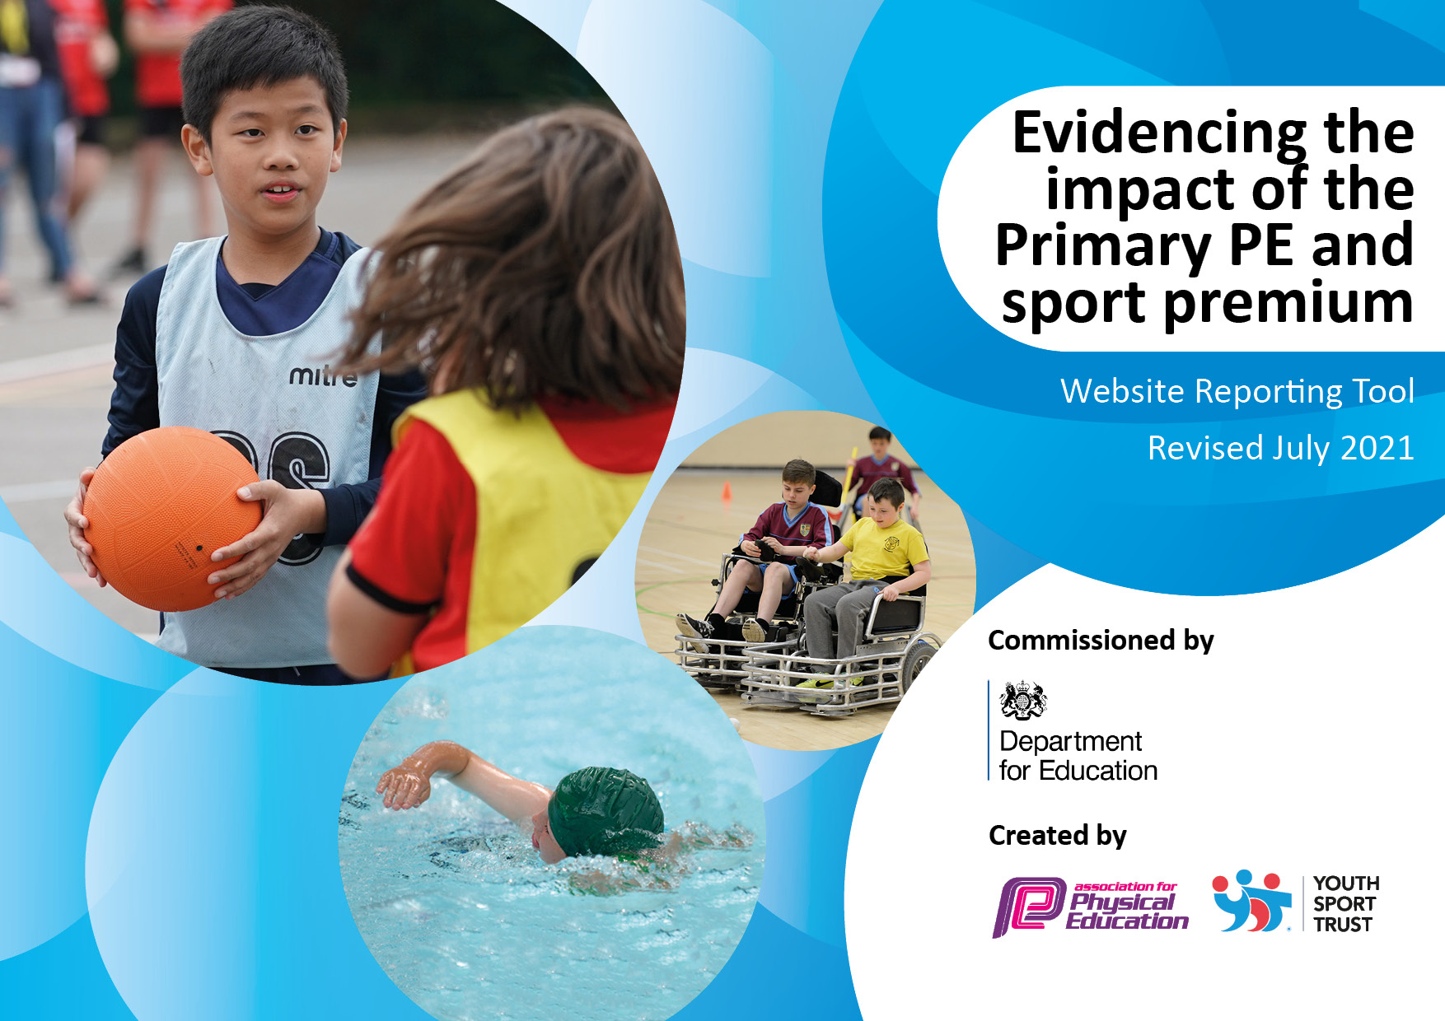
c
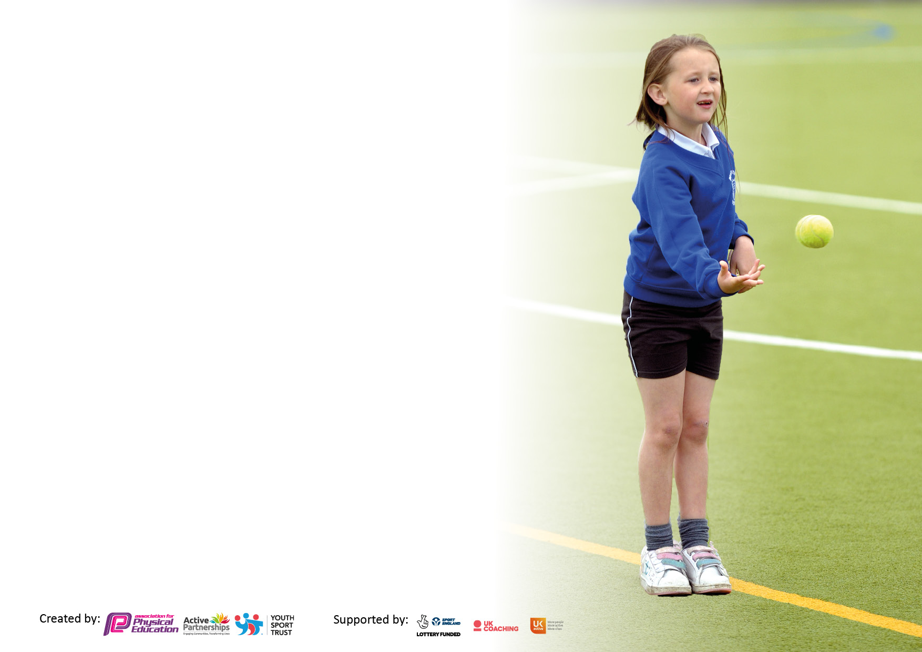

It is important that your grant is used effectively and based on school need. The Education Inspection Framework makes clear there will be a focus on ‘whether leaders and those responsible for governors all understand their respective roles and perform these in a way that enhances the effectiveness of the school’.

Under the Quality of Education Ofsted inspectors consider:
Intent - Curriculum design, coverage and appropriateness
Implementation - Curriculum delivery, Teaching (pedagogy) and Assessment
Impact - Attainment and progress

To assist schools with common transferable language this template has been developed to utilise the same three headings which should make your plans easily transferable between working documents.

Schools must use the funding to make additional and sustainable improvements to the quality of Physical Education, School Sport and Physical Activity (PESSPA) they offer. This means that you should use the Primary PE and sport premium to:

- Develop or add to the PESSPA activities that your school already offer
- Build capacity and capability within the school to ensure that improvements made now will benefit pupils joining the school in future years
- The Primary PE and sport premium should not be used to fund capital spend projects; the school’s budget should fund these.

Please visit gov.uk for therevisedDfEguidanceincludingthe5keyindicatorsacrosswhichschoolsshoulddemonstrate animprovement.Thisdocumentwillhelpyoutoreviewyourprovisionandtoreportyourspend.DfEencouragesschools to use this template as an effective way of meeting the reporting requirements of the Primary PE and sport premium.

We recommend you start by reflecting on the impact of current provision and reviewing the previous spend.

Schools are required to publish details of how they spend this funding, including any under-spend from 2019/2020, as well as on the impact it has on pupils’ PE and sport participation and attainment. All funding must be spent by 31st July 2023.

We recommend regularly updating the table and publishing it on your website throughout the year. This evidences your ongoing self-evaluation of how you are using the funding to secure maximum, sustainable impact. Final copy must be posted on your website by the end of the academic year and no later than the 31st July 2023. To see an example of how to complete the table please click HERE.

Details with regard to funding
Please complete the table below.

Total amount carried over from 2019/20 | £0
Total amount allocated for 2020/21 | £19,640
How much (if any) do you intend to carry over from this total fund into 2021/22? | £0
Total amount allocated for 2021/22 | £19,677
Total amount of funding for 2021/22. To be spent and reported on by 31st July 2022. | £19,677
Total amount allocated for 2022/23. | £
Swimming Data
Please report on your Swimming Data below.

Meeting national curriculum requirements for swimming and water safety.

N.B. Complete this section to your best ability. For example you might have practised safe self-rescue techniques on dry land which you can then transfer to the pool when school swimming restarts.
Due to exceptional circumstances priority should be given to ensuring that pupils can perform safe self rescue even if they do not fully meet the first two requirements of the NC programme of study
What percentage of your current Year 6 cohort swim competently, confidently and proficiently over a distance of at least 25 metres?  N.B. Even though your pupils may swim in another year please report on their attainment on leaving primary school at the end of the summer term 2020.  Please see note above | 26%
What percentage of your current Year 6 cohort use a range of strokes effectively [for example, front crawl, backstroke and breaststroke]?  Please see note above | 26%
What percentage of your current Year 6 cohort perform safe self-rescue in different water-based situations? | 27%
Schools can choose to use the Primary PE and sport premium to provide additional provision for swimming but this must be for activity over and above the national curriculum requirements. Have you used it in this way? | No

Action Plan and Budget Tracking
Capture your intended annual spend against the 5 key indicators. Clarify the success criteria and evidence of impact that you intend to measure to evaluate for pupils today and for the future.

Academic Year: 2022/23 | Total fund allocated: £13,205 | Date Updated: July 2023
Key indicator 1: The engagement of all pupils in regular physical activity – Chief Medical Officers guidelines recommend that primary school pupils undertake at least 30 minutes of physical activity a day in school |  |  |  | Percentage of total allocation:
 |  |  |  | 62%
Intent | Implementation |  | Impact
Your school focus should be clear what you want the pupils to know and be able to do and about  what they need to learn and to  consolidate through practice: | Make sure your actions to achieve are linked to your intentions: | Funding allocated: | Evidence of impact: what do pupils now know and what can they now do? What has changed?: | Sustainability and suggested next steps:
To offer a broad P.E. curriculum with extra-curricular opportunities to enable the children to meet the recommended physical activity guidelines.  Understanding the importance of physical activity on health & wellbeing  e.g. Daily Mile  Targeted initiatives – Mini-whispa (Inspire Together)  Extra-curricular opportunities.  Lunch time provision & After school clubs | P.E. teacher plans and delivers curriculum to all year groups.  Class teachers take children out to do the daily mile. The school takes part in national and daily mile celebration days.  Book targeted initiatives through the business manager (mini-whispa) and liaise with staff, SEND lead and pastoral team to select the right children to participate.  After-school activities delivered by P.E. teacher and support staff.  Lunch time activities delivered by sports leaders and lunch time supervisors | £100 – Mini-whispa  £0- Leicestershire county cricket & Leicester city hockey club. | P.E. Teacher ensures that:  All year groups have two timetabled slots per week. Timetables used and shared amongst staff to organise topics throughout the year so all areas in the national curriculum are covered.  Children have become more physically competent by practising a range of skills whilst gaining knowledge of various sports.  Registers for clubs and end of year report (school games mark, governor reports) show our extra-curricular provision.  Children can maintain their involvement in sport outside of the school provision – information on local clubs and activities.  Girl’s participation levels have continued to increase from last year. | P.E. teacher to continue to have key parts of the school sports provision in place – timetabled curriculum, continued extra-curricular opportunities, organising competitive involvement, staff CPD.  Continue to allow leadership opportunities for children during PE by letting them officiate a range of sports as well as run their own games.  Ensure there is a clear pathway from the curriculum/extra-curricular activities into further participation in local clubs.
Key indicator 2: The profile of PESSPA being raised across the school as a tool for whole school improvement |  |  |  | Percentage of total allocation:
 |  |  |  | %
Intent | Implementation |  | Impact
Your school focus should be clear what you want the pupils to know and be able to do and about  what they need to learn and to  consolidate through practice: | Make sure your actions to achieve are linked to your intentions: | Funding allocated: | Evidence of impact: what do pupils now know and what can they now do? What has changed?: | Sustainability and suggested next steps:
Importance of Sport & Physical Activity  Daily Mile  Health & Wellbeing  Reward Days | To celebrate achievements via certificates, social media etc.  Take part in local and national daily mile initiatives – National Daily Mile Day.  Targeted intervention for inactive groups (girls, SEND) where they take part in various activities and learn the important of health & wellbeing – linked with the pastoral team.  To ensure every child takes part in a competition – children work together to collect results and encourage each other.  Emphasise the importance of the school games values.  Use a P.E. reward day where children can choose an activity to take part in as a reward for their behaviour across the year. | £2000 | Photos and social media (school twitter, blog) posts to show achievements  Children take part in a range of activities and feel part of a team (classes).  Motivation to continue to take part and determination to try their best. Children demonstrate values through involvement.  School website contains information of achievements, future fixtures and our overall school sport provision.  Participation figures, competition involvement, curriculum and extra-curricular opportunities provided all included in reports. | Ensure all children have the opportunity to take part in competitions that allows them to demonstrate the school games values.  Opportunities provided by affiliations to sports partnerships and in school competition.

Key indicator 3: Increased confidence, knowledge and skills of all staff in teaching PE and sport |  |  |  | Percentage of total allocation:
 |  |  |  | 10%
Intent | Implementation |  | Impact
Your school focus should be clear | Make sure your actions to | Funding | Evidence of impact: what do | Sustainability and suggested
what you want the pupils to know | achieve are linked to your | allocated: | pupils now know and what | next steps:
and be able to do and about | intentions: |  | can they now do? What has
what they need to learn and to |  |  | changed?:
consolidate through practice:
P.E. teacher works alongside staff members to ensure they are confident in teaching a range of sports in the curriculum.  TA Level 2 member of staff involved in the P.E. curriculum and extra-curricular activities.  1:1 support staff also attend P.E. lessons and extra-curricular activities (clubs & competitions).  Staff members play an important role in the Daily Mile – ensuring that their class completes the activity throughout the week.  Staff to support external providers on targeted initiatives so they can organise and run the same programme in the future. | Class teachers to attend P.E. lessons, working alongside P.E. teacher to further improve understanding of P.E delivery (this was done as class teachers had to teach PE once a week for a term each).  Level 2 TA to attend lessons and gain knowledge across a variety of sports.  Ensure 1:1 support for children who require it so that they are engaged in the lesson. | £1700 | Staff feedback and assessments. Children receive better coaching and feedback.  Staff CPD available for all members of staff to have present knowledge of good practice in P.E.  Allows Level 2 TA to:  Offer better feedback for children during lessons and extra-curricular activities through improved knowledge in a range of sports. Provide 1:1 support when children require it.  Other 1:1 members of staff to help - Adapt lessons for 1:1 children when required to allow them to remain engaged. | Maintain staff involvement across the school.  Have staff attend courses and conferences to have present knowledge of P.E. to share with other members of staff.  P.E. teacher to continue working with members of staff.  Always have staff supporting targeted initiatives so they are able to continue a programme.
Key indicator 4: Broader experience of a range of sports and activities offered to all pupils |  |  |  | Percentage of total allocation:
Intent | Implementation |  | Impact
Your school focus should be clear | Make sure your actions to | Funding | Evidence of impact: what do | Sustainability and suggested
what you want the pupils to know | achieve are linked to your | allocated: | pupils now know and what | next steps:
and be able to do and about | intentions: |  | can they now do? What has
what they need to learn and to |  |  | changed?:
consolidate through practice:
To participate in a range of sports and activities through curriculum & extra-curricular opportunities.  Introduce new activities to the children.  Ensure staff are knowledgeable on the activities provided to ensure safe practice. | P.E. curriculum – provide a broad range of activities in line with the curriculum.  Investment into new equipment – used in P.E. curriculum time & extra-curricular opportunities (e.g., after school clubs & lunch time).  Ensure all activities are inclusive | £2000 | Introduction of new activities – photos, feedback forms.  Children have experienced a range of sports and can demonstrate different techniques.  Are knowledgeable about rules and formats. | Maintain equipment and identify what is needed for the following year to ensure extra-curricular provision is good and enjoyable.  To explore the option of additional members of staff running further clubs so more children are taking part.

Key indicator 5: Increased participation in competitive sport |  |  |  | Percentage of total allocation:
 |  |  |  | %
Intent | Implementation |  | Impact
Your school focus should be clear | Make sure your actions to | Funding | Evidence of impact: what do | Sustainability and suggested
what you want the pupils to know | achieve are linked to your | allocated: | pupils now know and what | next steps:
and be able to do and about | intentions: |  | can they now do? What has
what they need to learn and to |  |  | changed?:
consolidate through practice:
To participate in a range of sports competitions through memberships and affiliations (Inspire together, Active together & LCFC).  Ensure intra-school competition programme is organised to run throughout the year with support from staff and sport leaders.  Ensure transport is booked to be able to participate in competitions/festivals | Purchase the membership and ensure communication with our SGO regarding competitions.  Using children to collect scores – improving their sports leadership skills.  To submit scores using the results sheets provided by the competition organisers (Inspire together). To celebrate their involvement – via the school social media, certificates and school awards.  Liaise with office staff/business manger on booking transport and completing the appropriate risk assessments. | £1550  £450 | Photos, social media, registers, assemblies, newsletters.  Children have the experience of participating in a competitive event.  Children learn and demonstrate the school games values.  Sport Leaders learn important skills through supporting intra-school competitions.  Also, we sustained platinum for the school’s game marks. This shows our continued commitment to providing competitive sports opportunities for all children.  Enabled our teams to participate in competitions.  Competition Highlights 22/23:  Girl’s & mixed cricket East Leicester Winners  Year 5 boys 50m winner  Year 6 boys 50m winner  Year 6 boys 600m & standing long jump runner up  Year 5 80x5m 3rd place  Boys & Girl’s football semi finalists  Invited to represent East Leicester in the quickstick hockey competition at Summer champs (unfortunately unable to attend this event)  3rd place in East Leicester Netball  Made the East Leciester finals for basketball. | Ensure we purchase our membership in the Inspire together package to give children the opportunities available.  Ensure sport leaders are offered training and then given the opportunity to lead and support on intra-school competition.

Signed off by
Head Teacher: | Antony Corbett
Date: | 12.7.23
Subject Leader: | Inia Herbert
Date: | 12.7.23
Governor: | Lesley Butcher

